
TAMPINES JUNIOR COLLEGE

Preliminary Examinations 2010

CHEMISTRY (Higher 2) 9647/02

PAPER 2 Structured Questions

Tuesday 14 September 2010 2 hours

Additional materials: Data Booklet

INSTRUCTIONS TO CANDIDATES
Write your answers on the Question Paper.

Write your name and Civics Group on all the work you hand in.
Write in dark blue or black pen on both sides of the paper.
Do not use staples, paper clips, highlighters, glue or correction fluid.

Answer all questions.

The number of marks is given in brackets [ ] at the end of each question or part question.
Name : _____________________  CG : ________ |  | Question | Marks
 |  | 1
 |  | 2
 |  | 3
 |  | 4
 |  | 5
 |  | 6
 |  | 7
 |  | TOTAL | / 72

This document consists of 15 printed pages.
[Turn over

Answer all the questions in the space provided.

Question 1 [12 marks]

Planning

Hydrochloric acid reacts with solid calcium carbonate in the form of marble chips. The products of the reaction are aqueous calcium chloride, carbon dioxide and water.

The rate in which a reaction will proceed is dependent on many factors (variables). You are to plan an investigation to find how changes in one of these variables affect the rate of reaction between solid calcium carbonate and hydrochloric acid.

(a) Write a balanced equation, including state symbols, for the reaction between solid calcium carbonate and hydrochloric acid. [1]

_______________________________________________________________

(b)(i) The concentration of the hydrochloric acid is one independent variable that could be investigated. Identify two other independent variables that could be investigated. [2]
_______________________________________________________________

_______________________________________________________________

(ii) Identify a dependent variable that you could measure to follow the rate of reaction. [1]

_______________________________________________________________

(c) Propose a hypothesis that can be tested experimentally and that relates the rate of reaction and the concentration of the hydrochloric acid. [1]
_______________________________________________________________

_______________________________________________________________

(d) Design a laboratory experiment that you would use to investigate your hypothesis. You should draw a labelled diagram showing the arrangement of your apparatus. Your plan should include the following.

(i) a step-by-step description of the procedure you would follow
(ii) how you would measure and vary the independent variable
(iii) how you would control the other two variables that you identified in part (b)
(iv) any safety precautions that you would take
(v) appropriate quantities (masses, volumes, concentrations) to use in the experiment

[Ar: Ca, 40.1; C, 12.0; O, 16.0]
Hydrochloric acid has an approximate concentration of 2.0 mol dm⁻³.
[7]

______________________________________________________________________________________________________________________________________________________________________________________________________________________________________________________________________________________________________________________________________________________________________________________________________________________________________________________________________________________________________________________________________________________________________________________________________________________________________________________________________________________________________________________________________
_____________________________________________________________________________________________________________________________________________________________________________________________________________________________________________________________________________________________________________________________________________________________________________________________________________________________________________________________________________________________________________________________________________________________________________________________________________________________________________________________________________________________________________________________________________________________________________________________________________________________________________________________________________________________________________________________________________________________________________________________________________________________________________________________________________________________________________________________________________________________________________________________________________________________________________________________________________________________________________________________________________________________________________________________________
___________________________________________________________________________________________________________________________________________________________________________________________________________________________________________________________________________________________________________________________________________________________________
Question 2 [10 marks]

In catalytic hydrogenation of benzene as shown below, a catalyst known as Raney nickel is commonly used. Raney nickel is produced when a block of nickel-aluminium alloy is treated with concentrated sodium hydroxide.

The aluminium-containing product of this reaction is the same as that obtained from the reaction between aluminium oxide and sodium hydroxide. The porous structure of the catalyst arises from the selective removal of aluminium from alloy particles using concentrated sodium hydroxide solution.

When a 2.50 g sample of this alloy was reacted with concentrated sodium hydroxide, 0.0500 mol of hydrogen gas was produced at 28 ºC and a pressure of 1.5 atm.

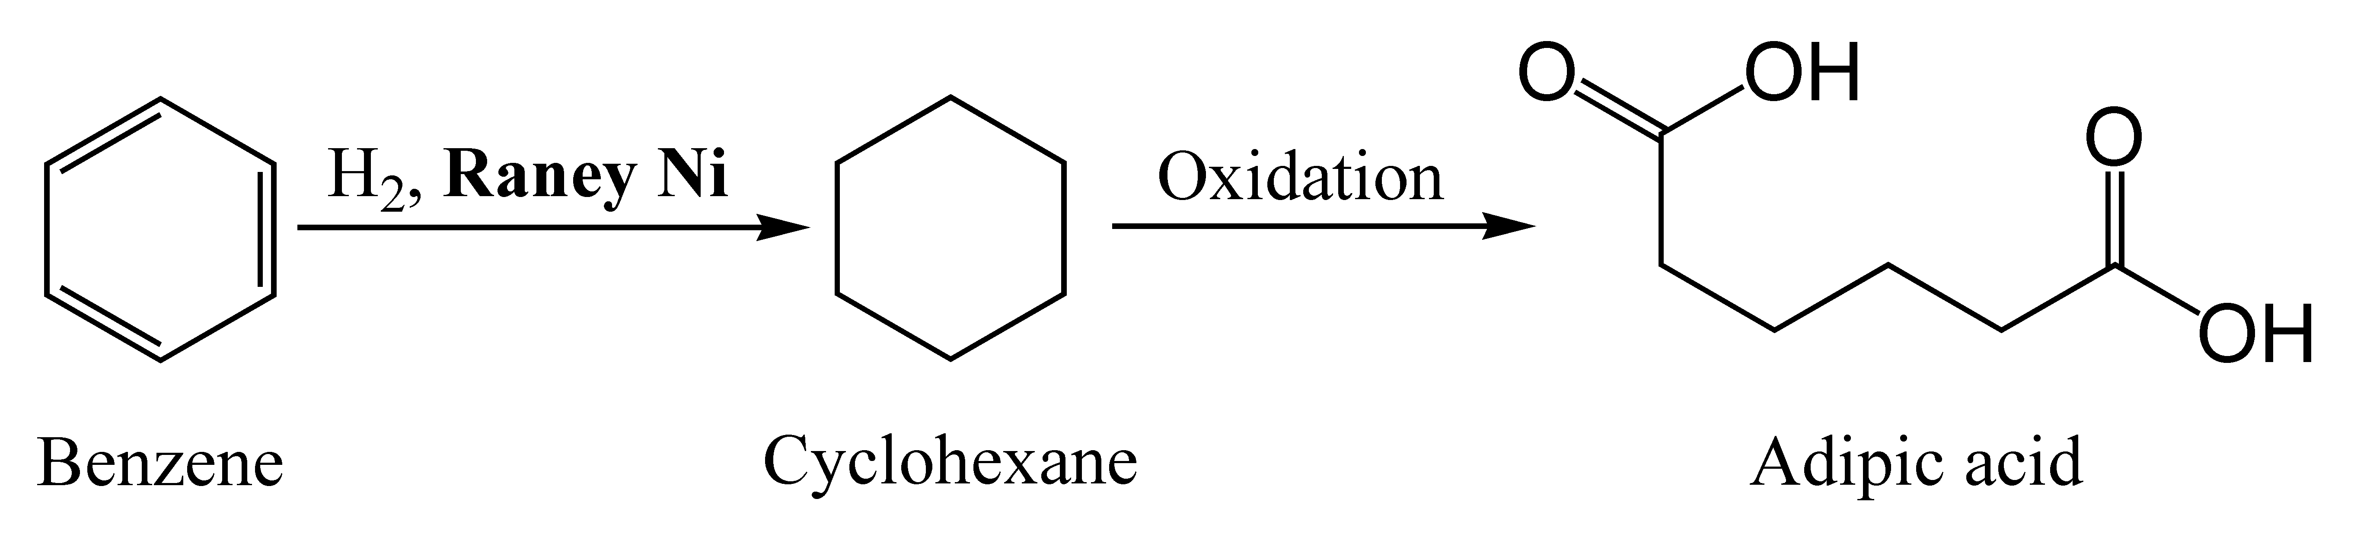
3 steps

(a) | Construct a balanced equation for the reaction between aluminium and sodium hydroxide. [1]  _______________________________________________________________
(b) | Calculate the volume of hydrogen gas obtained in cm³. [2]
(c) | Hence calculate the percentage composition of aluminium in the sample of alloy. [2]
Today, the typical modern ammonia-producing plant first converts natural gas (i.e., methane) or liquefied petroleum gas (such gases are propane and butane) or petroleum naphtha into gaseous hydrogen. Catalytic hydrogenation converts gaseous organosulfur compounds such as CH₃CH₂SH into its corresponding hydrocarbon and hydrogen sulfide.
(d) | Construct the equation, with state symbols for the above reaction. [1]  _______________________________________________________________
(e) | Write the K_{p} expression for the above reaction. [1]
(f) | A 1:1 mixture of H₂ and CH₃CH₂SH was allowed to reach equilibrium at 500 ⁰C and a total pressure of 4 atm. The partial pressure of H₂S at equilibrium was found to be 1.25 atm. Calculate the K_{p} value. [2]
(g) | Predict and explain whether an increase in pressure will affect this equilibrium.  [1] _______________________________________________________________  _______________________________________________________________
Question 3 [7 marks]

Spinach, along with other green leafy vegetables, is considered to be a rich source of iron. However, spinach contains iron absorption inhibiting substances, including high levels of oxalate which can bind to the iron to form ferrous oxalate, which renders much of the iron in spinach unusable by the body.

A 35.0 cm³ sample of iron (II) oxalate, FeC₂O₄ extracted from 150 g of spinach, was diluted in water and the solution made up to 250 cm³. A 25.0 cm³ portion of this solution was acidified and titrated with 13.45 cm³ of 0.020 mol dm⁻³ potassium manganate (VII) to give a yellow solution.
(a) | State the change in oxidation number for manganese and carbon. [2]  _______________________________________________________________  _______________________________________________________________  _______________________________________________________________
(b) | Write an overall equation for the reaction between potassium mangante(VII) and iron (II) oxalate. [1]  _______________________________________________________________
(c) | Calculate the concentration, in mol dm⁻³, of iron (II) oxalate in the original sample. [3]
(d) | Calculate the number of moles of iron in each gram of spinach. [1]
Question 4 [8 marks]

(a) The graph below shows a plot of the atomic radii of the elements from sodium to chlorine.

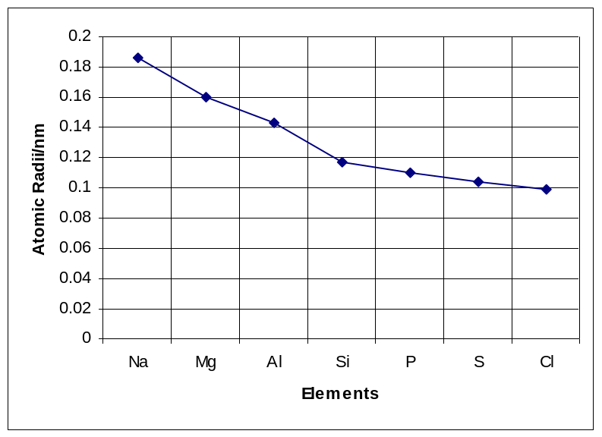

(i) Explain the general trend in atomic radii of these elements across the period.[2]

_______________________________________________________________

_______________________________________________________________

_______________________________________________________________

_______________________________________________________________

(ii) Using the Data Booklet, plot the ionic radii of these elements in the same graph
above. [1]

(iii) Comment on the shape of the graph that you plotted in (ii). [2]

_______________________________________________________________

_______________________________________________________________

_______________________________________________________________

_______________________________________________________________

_______________________________________________________________

_______________________________________________________________
(b) | Phosphorus pentachloride is a dangerous substance as it reacts violently with water to produce white steamy fumes. It is used as a chlorinating agent and as a catalyst. One common use of phosphorus pentachloride is in the manufacture of chlorophosphazenes, a group of flame retardants.
(i) Explain why PCl₅ exists in nature but NCl₅ does not exist. [2]
_______________________________________________________________

_______________________________________________________________

(ii) Write a balanced equation to show the reaction of PCl₅ in water. [1]
_______________________________________________________________

Question 5 [9 marks]

The structural formula of a compound R is shown below.
O
O
OH
O

CH₂ – C – CH₃

(a) Compound R undergoes a 2 step reaction to produce Compound Z. Draw the intermediate product and state the reagents and conditions used for both steps.
[3]
O
O
OH
O
intermediate product
Step 1

CH₂ – C – CH₃

Compound R
Step 2
O
O
OH
Step 1: _______________________

Step 2:________________________ CH₂CHCH₂

Compound Z
(b) | Draw the structural formula(e) of the organic product(s) formed when compound R reacts with each of the following reagents. [6]

Reagent | Structural formula(e) of the organic product(s)
Aqueous alkaline I₂
Acidified potassium dichromate(VI), reflux
Ethanoyl Chloride
Aqueous NaOH, reflux
Thionyl chloride

Question 6 [11 marks]

(a) Maleic acid or cis-butenedioic acid is an organic compound that is a dicarboxylic acid. Maleic acid has become a new acidulant in the food and beverage industry. It can enhance special fruit aroma and improve the taste in food and beverage. Maleic acid is mainly used in syrup, readytea, orange juice, sports beverage and other fortified syrup and food.

(i) Draw the structure of cis-butenedioic acid. [1]

(ii) Fumaric acid is the trans isomer and its physical properties are very different fom maleic acid. The melting point of maleic acid is about 140 °C whereas the melting point of fumaric acid is 287 °C.
Explain why there is a difference in melting point for these two isomers. [2]
_______________________________________________________________

_______________________________________________________________

_______________________________________________________________

(iii) In industry, maleic acid is derived from maleic anhydride by hydrolysis.
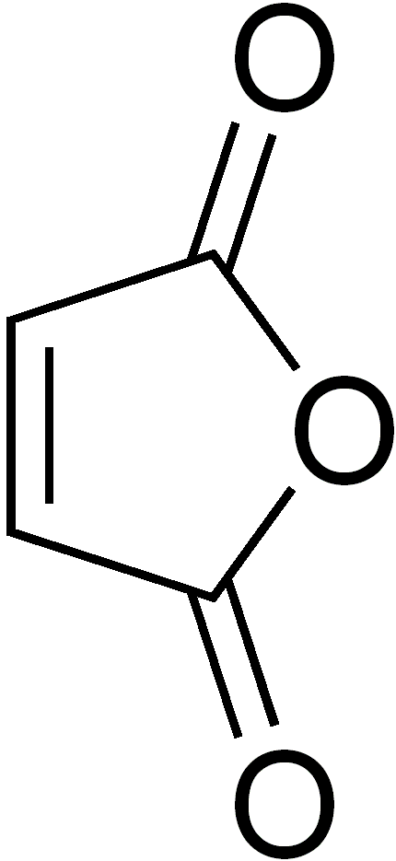 maleic anhydride
By means of a simple chemical test, show how you would distinguish maleic anhydride from maleic acid. [2]
______________________________________________________________

______________________________________________________________

______________________________________________________________

(b) | Novocaine is a synthetically created derivative of cocaine and is used as an anesthetic in minor surgeries.  Novocaine H₂N C−O−CH₂CH₂ −N(CH₂CH₃)₂  ll  O
(i) Besides the phenyl group, name the functional groups present in Novocaine. [1]

_______________________________________________________________

(ii) Compare and explain the basicity of Novocaine to that of phenylamine. [2]

_______________________________________________________________

_______________________________________________________________

_______________________________________________________________

(iii) Give the structural formula of the two products formed when Novocaine is
refluxed with aqueous hydrochloric acid and state the type of reaction(s). [3]

Type of reaction(s): _______________________________________________

QUESTION 7 [15 marks]

Glucose (C₆H₁₂O₆) is a simple sugar which is used as a source of energy in most organisms and a metabolic intermediate. The melting point of glucose is 146 ^{O}C.
The structure of glucose is shown below:

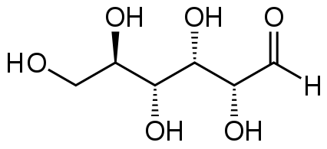

An example of the dehydration of a glucose molecule can be seen from the equation below.
∆H₁
CH₂OH(CH(OH))₄CHO CH₂=C(OH)-CH=C(OH)-CH(OH)-CHO + 2H₂O
Glucose Compound A

(a) Write an equation to define the standard enthalpy change of formation of
glucose. [1]

_______________________________________________________________
(b) Using the value(s) given below, calculate ∆H₁. [2]

Enthalpy change of formation of Glucose | -1271 kJ mol⁻¹
Enthalpy change of formation of Compound A | -1085 kJ mol⁻¹
Enthalpy change of combustion of H₂(g) | -286 kJ mol⁻¹
Enthalpy change of atomization of C(s) | +715 kJ mol⁻¹

(c) Use the data given in (b) and any relevant values from the Data Booklet, draw
an appropriate energy cycle and hence, find the enthalpy change of
sublimation of glucose. [5]

(d) State the total possible number of stereoisomers that glucose can display. [1]

_______________________________________________________________

(e) Complete the following scheme by drawing the structures of the organic
compounds B, C, D, E, F and G in the boxes provided. [6]

CH₂=C(OH)-CH=C(OH) -CH(OH)-CHO compound A

KMnO₄/H⁺, heat

Compound B

PCl₅

Compound C

OH
excess (CH₃)₂NH,
heat in a sealed tube

HCN with NaCN, followed by heating with dilute acid

Compound D

Comp
Compound F and Compound G

Compound E

